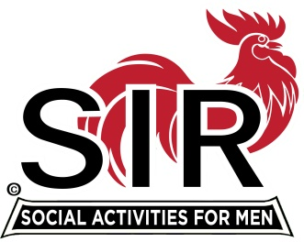
Las Trampas Branch 116
BEC Meeting Agenda
August 23rd, 2022, 9:15 AM at Boundary Oaks

The Mission of SIR is to enhance the lives of our members through fun activities, events and luncheons – while making friends for life.

9:15 am Call to order; Secretary, Paul Ramacciotti, confirm a quorum and Approval of July 18th 2022 BEC meeting minutes
9:20 Standing Reports
- Treasurer - Alan Fitzgerald – Financial Update
- Membership – Phil Goff
- RAMP Department Head Reports:
- Recruitment, Don Schroeder
- Activity Coordinator Mike Ward and Jeff Johnson
- Member Relations David Harris
- Publicity Al Farbman notes
- Covid Compliance - Kevin Donahue (BA.5 and any related updates etc.)

9:35 Old Business

- Lunch Estimate Risks and August/Sept Boundary accommodation (Mike Schneider)
  - Late cancellations after Thursday prior to Luncheon
  - Count accuracy or RSVP?

9:45 Little SIR Updates – Roger Craig
Speaker Update (Roger Craig, Paul Freitas)
Birthday Boys
9:50 Misc. Updates & New Business

- Vote for Officer Slate at Membership Meeting
- Christmas Party
- Question of Luncheon Attendance (required or an activity)
- Review letter responses and member disposition
- Guest and new member lunch reimbursement policy review

- Boundary Oaks Branches, Area Branches, and Overlapping Opportunities
  - Contact Plan for Activity Sharing
- Volunteers Needed: Recruiting Assistants, Speaker Team Member, Member Relations Assistants

10:15 am Adjourn; For Lunch Preparations

